**Beaulieu College**

**Mathematics Department**

**GRADE 12**

**ADVANCED PROGRAMME MATHEMATICS**

**Preliminary Examination**

Time: 3 Hours 300 marks

Date: 11 July 2014

Examiner: Ms A Smith Moderator: Mr J Ruiz-Mesa

**PLEASE READ THE FOLLOWING INSTRUCTIONS CAREFULLY**

1. This question paper consists of 13 pages, including an answer sheet. An information sheet is also included.

2. Answer all the questions on the folio pages except Question 2.2 and Question 8.3. These questions must be answered on the **ANSWER SHEET**.

3. Approved, non-programmable, non-graphical calculators may be used, unless otherwise stated.

4. Diagrams are not drawn according to scale.

5. Work neatly and show all the necessary steps in your calculations.

6. If applicable, calculations should be done using radians and answers should be given in radians.

7. Write your name on the question paper, **ANSWER SHEET** and folio pages.

8. Round off answers as indicated in each question.

9. Good luck!

**MODULE 1 CALCULUS AND ALGEBRA**

**Question 1**

Use mathematical induction to prove that:

 is always divisible by  for all . (12)

**[12]**

**Question 2**

2.1 Solve for , without the use of a calculator:

(a) . (8)

(b)  (5)

2.2 Given: .



On the **Answer Sheet** provided draw the graph of , clearly showing AND labelling any intercepts with the axes as well as asymptotes. (10)

2.3 Given:  and 

(a) Determine . (2)

(b) Explain why  is a decreasing function. (3)

(c) What is the range of ? (4)

**[32]**

**Question 3**

3.1 Determine the sum . (6)

3.2 Given  with a zero at .

Determine the values of  and . (12)

**[18]**

**Question 4**

Given the function: 

4.1 Determine the value of  if  is continuous at . (6)

4.2 Assuming that , determine whether  is differentiable at .

Justify your answer mathematically. (8)

**[14]**

**Question 5**

5.1 (a) Prove that  (6)

(b) Henceforth, determine  (2)

5.2 Determine . It is not necessary to simplify your answers:

(a)  (4)

(b)  (7)

5.3 The function  defines  as a function of .

(a) Determine . (8)

(b) Hence determine the equation of the tangent at . (5)

**[32]**

(*Please turn over for Question 6.*)

**Question 6**

In the given sketch, the functions  and  are given for . The two functions do not intersect anywhere on this interval. G is a point on the graph of  and H is a point on the graph of  such that GH is a vertical line.

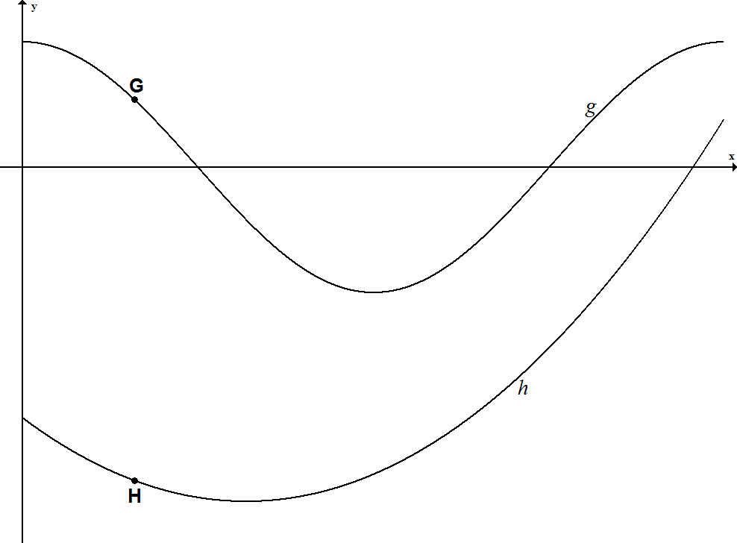

6.1 Show that the maximum length of the line GH can be determined by solving the equation . (6)

6.2 Use Newton’s method to write down a recursive equation that can be used to solve the equation in 6.1. (6)

6.3 Hence, using  as an initial value, determine the answer of the equation in 6.1 correct to five decimal places. (3)

**[15]**

**Question 7**

A circle with a radius of  units and a centre at point O is shown below. The chord AB subtends an angle of  radians at O.





Show that the perimeter of the shaded region can be expressed as . (8)

**[8]**

(*Please turn over for Question 8.*)

**Question 8**

Given: 

 has no stationary points, but it has a point of inflection at .

8.1 Calculate the approximate -value of the point of inflection, rounded off to two decimal places. (2)

8.2 Determine and write down all the intercepts with the axes and equations of the horizontal and vertical asymptotes. (7)

8.3 Hence, on the **Answer Sheet** provided, draw a sketch graph of , showing all the intercepts, asymptotes, and the point of inflection. (8)

8.4 If it is given that , determine the equation of the oblique asymptote of . (8)

**[25]**

**Question 9**

Determine the following integrals:

9.1  (8)

9.2  (5)

9.3  (10)

9.4  (6)

**[29]**

**Question 10**

The following sketch shows the graph of  , which cuts the axes at the origin. The shaded region is the area between the graph, the -axis and the line .



10.1 Determine the area of the shaded region in terms of . (9)

10.2 Hence, or otherwise, calculate the area if  correct to three decimal places. (2)

10.3 Set up, but do not integrate or calculate, an expression that represents the volume of a solid that will be formed if the shaded region is rotated around the -axis. (4)

**[15]**

**Total for Module 1: [200]**

**MODULE 2 STATISTICS**

**(All answers should be rounded off to four decimal places.)**

**Question 11**

Megan and Paige are analysing the times a sample of grade 11s and grade 12s spent preparing for their Mathematics examination. Their data is summarised in the table below:

|  |  |
| --- | --- |
| **Grade 11s** | **Grade 12s** |
| hours | hours |
| hours | hours |
| learners | learners |

Paige concludes on the basis of this data that grade 12s study longer when preparing for their Mathematics examination than grade 11s do. Megan is more cautious. She feels the difference between the means should also be tested at a 3% level of significance.

11.1 Explain why Megan is wise to do a further test. (3)

11.2 Conduct the appropriate hypothesis test to help clarify Megan’s decision about whether there is a significant difference in the times grade 11s and grade 12s spend preparing for their Mathematics examinations. (10)

**[13]**

**Question 12**

Liam, a market researcher for a ladies clothing brand, conducted a study where he obtained data from 550 ladies at a local mall.

12.1 He found that 392 ladies preferred wearing pants to work rather than skirts. Determine an approximate 90% confidence interval for the proportion of ladies who do **not** prefer to wear pants to work. The following formula may be used:



(10)

12.2 He found the 98% confidence interval for the amount of money in rand that each lady spends on clothing per month, to be .

(a) Determine the average money spent per lady in rand. (2)

(b) Determine the standard deviation for this data. (6)

**[18]**

**Question 13**

Given that: ;  and 

13.1 Determine  in terms of . (5)

13.2 Determine  in terms of . (3)

13.3 Hence, or otherwise, determine . (9)

13.4 Determine . (3)

**[20]**

**Question 14**

A random variable has a probability density function given by:



14.1 Show that . (7)

14.2 Determine the median. (9)

**[16]**

**Question 15**

15.1 Ross is an excellent defender. The probability that Ross will prevent a goal from being scored against his hockey team is 88%.

If Ross defends 12 attempts at goal in a hockey match, what is the probability that the other team will score exactly 3 goals? (7)

15.2 Prio has a jar filled with chocolates. It contains 25 caramel filled chocolates and 15 plain chocolates. Alistair randomly steals 6 chocolates out of the jar.

Determine the probability that Alistair stole no caramel filled chocolates. (7)

15.3 Manala wants to apply to study medicine. She discovers that the universities only enrol students who score within the top 5% of the National Benchmark Test or NBT. It is known that the NBT scores are normally distributed, with a mean of 126 and a standard deviation of 16,2.

What must Manala’s minimum NBT score be to be accepted to study medicine? (7)

**[21]**

**Question 16**

16.1 At the matric dance, 10 people (5 couples) are arranged at random in a line for a photograph.

Determine the probability that each female is standing next to her partner. (6)

16.2 Robert wants to start an action cricket league. He has 24 people interested in joining the league.

Determine the number of ways that he can arrange the 24 interested people into three groups of eight. (6)

**[12]**

**Total for Module 2: [100]**

**ANSWER SHEET**

Name: _________________________________________________ Grade 12

**MODULE 1**

**Question 2.2**



(10)

**Question 8.3**



(9)